**----------------------------------------------------------------------------------------------------------------**

create or replace PROCEDURE create_hotel(

street_address in varchar2,

city in varchar2,

state in varchar2,

zip_code in varchar2,

phone_number in varchar2,

max_small_room_avail in number,

max_medium_room_avail in number,

max_large_room_avail in number

)

--Creates a hotel give the following information

--@param street_address - the address of the street

--@param city, the city the hotel is located in

--@param state, the state the hotel is located in

--@param zip_code, the zipcode the hotel is located in

--@param phone_number, the phone number of the hotel

--@param max_small_room_avail, the number of small rooms available for a hotel

--@param max_medium_room_avail, the number of medium rooms available for a hotel

--@param max_large_room_avail, the number of large rooms available for a hotel

AS

able_to_insert_hotel boolean := true;

BEGIN

--check to make sure all values are not null

if(street_address is null) then

able_to_insert_hotel := false;

dbms_output.put_line('Street Address is null, please add a street address');

elsif(city is null) then

able_to_insert_hotel := false;

dbms_output.put_line('city is null, please add a city');

elsif(state is null) then

able_to_insert_hotel := false;

dbms_output.put_line('State is null, please add a state');

elsif(zip_code is null) then

able_to_insert_hotel := false;

dbms_output.put_line('Zip code is null, please add a zip code');

elsif(length(zip_code) > 5) then

able_to_insert_hotel := false;

dbms_output.put_line('Zip code length is too long, please enter a valid zip code');

elsif(phone_number is null) then

able_to_insert_hotel := false;

dbms_output.put_line('Phone number is null, please add a phone number');

elsif(max_small_room_avail is null) then

able_to_insert_hotel := false;

dbms_output.put_line('Number of medium rooms available is null, please add number of medium rooms available');

elsif(max_medium_room_avail is null) then

able_to_insert_hotel := false;

dbms_output.put_line('Number of medium rooms available is null, please add number of medium rooms available');

elsif(max_large_room_avail is null) then

able_to_insert_hotel := false;

dbms_output.put_line('Number of large rooms available is null, please add number of large rooms available');

end if;

if(able_to_insert_hotel) then

INSERT INTO HOTEL --(hotel_id, street_address, city, state, zip_code, phone_number, max_small_room_avail, max_medium_room_avail, max_large_room_avail)

VALUES (hotel_id_seq.nextval, street_address, city, state, zip_code, phone_number, max_small_room_avail, max_medium_room_avail, max_large_room_avail);

else

dbms_output.put_line('Unable to insert hotel with the provided following info: ' || chr(10) ||

'street_address: ' || street_address || chr(10) ||

'city: ' || city || chr(10) ||

'state: ' || state || chr(10) ||

'zip_code: ' || zip_code || chr(10) ||

'phone_number: ' || phone_number || chr(10) ||

'max_small_room_avail: ' || max_small_room_avail || chr(10) ||

'max_medium_room_avail: ' || max_medium_room_avail || chr(10) ||

'max_large_room_avail: ' || max_large_room_avail);

end if;

EXCEPTION

WHEN DUP_VAL_ON_INDEX

THEN dbms_output.put_line('Hotel already exists!');

END;



SET serveroutput ON;

CREATE OR REPLACE function find_hotel(

find_street_address in varchar2,

find_city in varchar2,

find_state in varchar2,

find_zip_code in varchar2

)

--Find a hotel based on the following information

--@param street_address, the address of the hotel

--@param city, the city the hotel is located in

--@param state, the state the hotel is located in

--@param zip_code, the zip code of the city

--@return number, the hotel_id

RETURN number

IS

h_id number;

BEGIN

select hotel.hotel_id

into h_id

from hotel hotel

where hotel.street_address = find_street_address and

hotel.city = find_city and

hotel.state = find_state and

hotel.zip_code = find_zip_code;

dbms_output.put_line('Hotel Id: ' || h_id);

return h_id;

EXCEPTION

when no_data_found

then dbms_output.put_line('Hotel not found');

END;

declare

find_street_address varchar2(100) := '1000 Hilltop Circle';

find_city varchar2(50) := 'Baltimore';

find_state varchar2(2) := 'MD' ;

find_zip_code varchar2(5) := '21250';

hotel_id number;

begin

hotel_id := find_hotel(find_street_address, find_city, find_state, find_zip_code);

dbms_output.put_line('Looking for Hotel id with information:' || chr(10) ||

'---------------------------------------------------------' || chr(10) ||

'street_address: ' || find_street_address || chr(10) ||

'city: ' || find_city || chr(10) ||

'state: ' || find_state || chr(10) ||

'zip_code: ' || find_zip_code);

if(hotel_id is not null) then

dbms_output.put_line('---------------------------------------------------------');

dbms_output.put_line('Hotel found! Id: ' || hotel_id);

end if;

end;

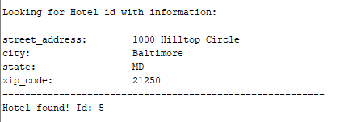

SET serveroutput ON;

CREATE OR REPLACE PROCEDURE display_hotel(

h_id number

)

--Display a hotels details based on the hotel_id

--@param hotel_id the id of the hotel

AS

hotel_information hotel%rowtype;

BEGIN

select *

into hotel_information

from hotel hotel

where hotel.hotel_id = h_id;

dbms_output.put_line(

'Hotel information' || chr(10) ||

'--------------------------------------------------' || chr(10) ||

'street_address : ' || hotel_information.street_address || chr(10) ||

'city : ' || hotel_information.city || chr(10) ||

'state : ' || hotel_information.state || chr(10) ||

'zip_code : ' || hotel_information.zip_code || chr(10) ||

'phone_number : ' || hotel_information.phone_number || chr(10) ||

'max_small_room_avail : ' || hotel_information.max_small_room_avail || chr(10) ||

'max_medium_room_avail: ' || hotel_information.max_medium_room_avail || chr(10) ||

'max_large_room_avail : ' || hotel_information.max_large_room_avail || chr(10) ||

'--------------------------------------------------'

);

EXCEPTION

when no_data_found

then dbms_output.put_line('Hotel with id:' || h_id || ' not found');

END;

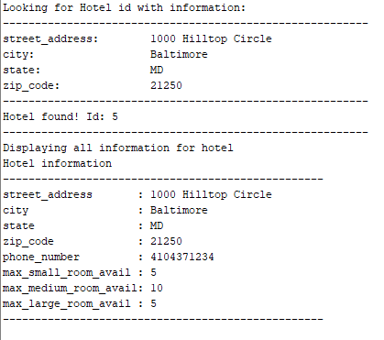

--solution 7

--- Procedure for creating a reservation ---

--- Creates event based on the all the input parameters required for creating a reservation.---

--- Prints the event reservation confirmation with the reservation ID----

create or replace procedure

reserve_for_event

(

hotelid in hotel.hotel_id%type,

hostname in hosts.host_name%type,

startdate in event_reservation.START_DATE%TYPE,

enddate in event_reservation.END_DATE%TYPE,

dateofreservation in event_reservation.DATE_OF_RESERVATION%TYPE,

numofsmallroom in event_reservation.NUM_SMALL_ROOMS%TYPE,

numofmediumroom in event_reservation.NUM_MEDIUM_ROOMS%TYPE,

numoflargeroom in event_reservation.NUM_LARGE_ROOMS%TYPE,

dis in event_reservation.discount%type,

numberofpeopleattending IN event_reservation.NUM_OF_GUESTS%TYPE ,

eventname in event_type.event_name%type,

eventreservationid out event_reservation.event_reservation_id%type

)

-- @param hotelid

-- @param host name

-- @param start date

-- @param end date

-- @param reservation date

-- @param numbers of small rooms

-- @param numbers of medium rooms

-- @param numbers of large rooms

-- @param discount

-- @param no of people attending

-- @param event name

-- @param reservation id

as

eventid event_type.event_id%type;

hostid hosts.host_id%type;

begin

select event_id into eventid from event_type where event_name = eventname;

select host_id into hostid from hosts where host_name = hostname;

--- Using the sequence to generate the reservation ID ---

eventreservationid := event_reservation_id_seq.nextval;

--- inserting the data after creating the reservation ---

insert into event_reservation

values (eventreservationid, hotelid, hostid, startdate, enddate, dateofreservation, numofsmallroom, numofmediumroom , numoflargeroom, dis, numberofpeopleattending, eventid);

update hotel set max_small_room_avail = max_small_room_avail - numofsmallroom;

update hotel set max_medium_room_avail = max_medium_room_avail - numofmediumroom;

update hotel set max_large_room_avail = max_large_room_avail - numoflargeroom;

end;

--- output of the reservation confirmation ---

Declare

res_id number;

Begin

reserve_for_event(5,'Kajal Pansare', date '2006-08-10', date '2006-08-13', date '2006-08-10',4, 2, 6, 5, 2,'Birthday', res_id);

Dbms_output.put_line('Event Reservation Completed, Event Registraion id is : ' || res_id);

End;

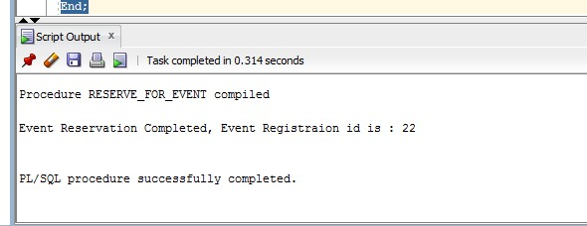

--solution8

--- Procedure for checking the event for the reservation ---

create or replace procedure

Check_event_reservation

(

hostname in hosts.host_name%type,

dateofres in event_reservation.date_of_reservation%type,

hotelid in hotel.hotel_id%type

)

is

---@param name of the host

---@param reservation date

---@param hotelid

--- Explicit cursor to fetch and hold the required data---

cursor c1 is select e.event_reservation_id from event_reservation e, hosts h where e.host_id=h.host_id

and h.host_name = hostname and e.hotel_id = hotelid and e.date_of_reservation = dateofres;

eventreservationid event_reservation.event_reservation_id%type;

begin

Open c1;

Loop

--- Fetching the reservation id from the cursor---

fetch c1 into eventreservationid;

exit when c1%notfound;

dbms_output.put_line('Event Reservation ID is: ' || eventreservationid );

end loop;

close c1;

--- Handling the exception ---

exception

when no_data_found then

dbms_output.put_line('No event reservation found');

end;

exec Check_event_reservation('George Karabatis',date '2006-08-10',5);

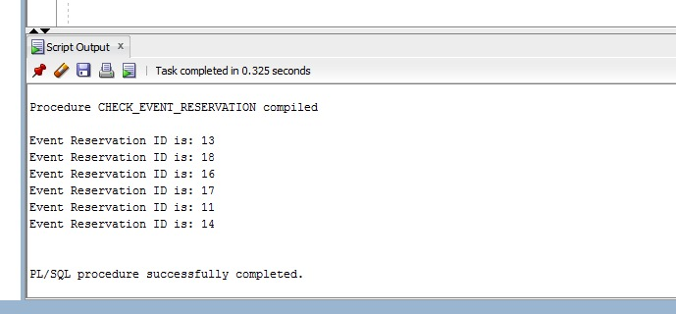

Priyanka Ranade ( Member 3)

**-------------------------------------------------------------------------------------------------------------------------------**

--Procedure print_event

--Show events by person: given a hosts name as an input, find all events under that name

--Print event reservation ID and event name for each event per host

create or replace procedure print_event(v_hname hosts.host_name%type)

is

cursor c1 is select event_reservation_id, event_name

from event_type,event_reservation, hosts where

hosts.host_id=event_reservation.host_id and event_type.event_id = event_reservation.event_id and host_name=v_hname;

--@param event_reservation_id - unique id for reservation

--@param event_name - string name of the event

--@param host_id - unique id for host

--@param event_id- unique id for event

--variables to hold output from cursor.

--of type event_id and event_name from event_type table

v_event_res_id event_reservation.event_id%type;

v_event_name event_type.event_name%type;

begin

open c1;

Loop

--fetching cursor into holding variables v_event_Res_id and v_event_name

fetch c1 into v_event_res_id,v_event_name;

exit when c1%notfound;

--print event id and name of the event`

dbms_output.put_line('Event Reservation ID is: ' || v_event_res_id || ' and ' || 'Event Name is: ' || v_event_name );

end loop;

close c1;

exception

when no_data_found then

dbms_output.put_line('No events for given employee');

end;

**-- Screenshots of Execution Statements and Output**

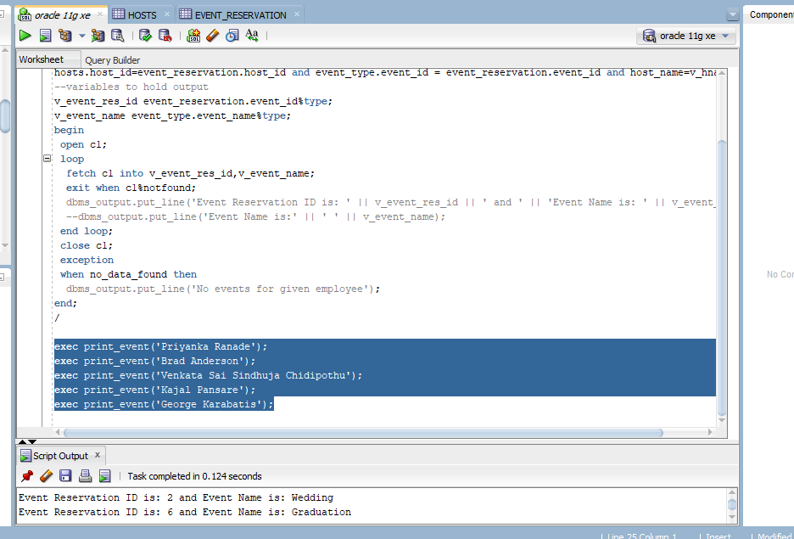

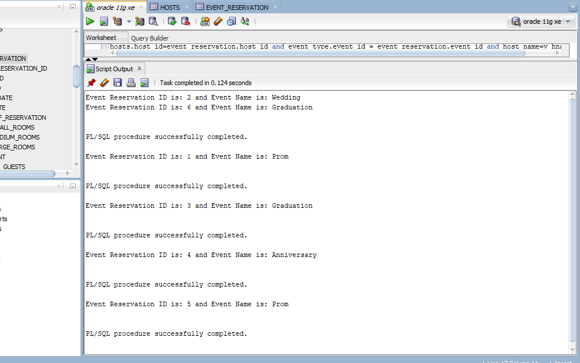

-- Procedure print_event_type

--Show specific event: Given an event type (Birthday, Wedding, etc.)

--display all events of that type in all hotels along with the address of the hotel and the date of the event

-- Taking an event type (Birthday, Wedding, etc) as input, joining event_reservation, event_type, and hotel tables

-- to show events of input type, hotel address, and date of event in all hotels

create or replace procedure print_event_type(v_ename event_type.event_name%type)

is

cursor c1 is select event_name,street_address,city,state,zip_code,start_date

from event_reservation, event_type, hotel

where event_name= v_ename

and event_reservation.event_id = event_type.event_id

and event_reservation.hotel_id = hotel.hotel_id;

--@param event_reservation_id - unique id for reservation

--@param event_name - string name of the event

--@param event_id - unique event id

--@hotel_id - unique id for hotel

--variables to hold output

v_event_name event_type.event_name%type;

v_street_addr hotel.street_address%type;

v_city hotel.city%type;

v_state hotel.state%type;

v_zip_code hotel.zip_code%type;

v_start_date event_reservation.start_date%type;

--using cursor to fetch records of input event type

begin

open c1;

loop

fetch c1 into v_event_name,v_street_addr,v_city,v_state,v_zip_code,v_start_date;

exit when c1%notfound;

--dbms_output.put_line('Event Reservation ID is: ' || v_event_res_id || ' and ' || 'Event Name is: ' || v_event_name );

dbms_output.put_line('Event Type: ' || v_event_name || ',' || ' Street Address: ' || v_street_addr || ',' || ' City: ' || v_city || ',' || ' State: ' || v_state || ',' || ' Zip Code: ' || v_zip_code || ',' || ' Event Date: ' || v_start_date);

end loop;

close c1;

exception

when no_data_found then

dbms_output.put_line('No events of that type');

end;

**--Screenshot of Execution Statements and Output**

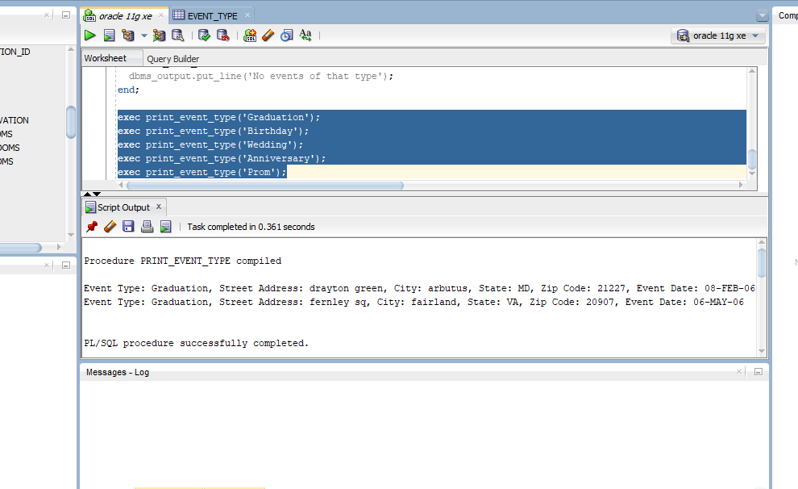

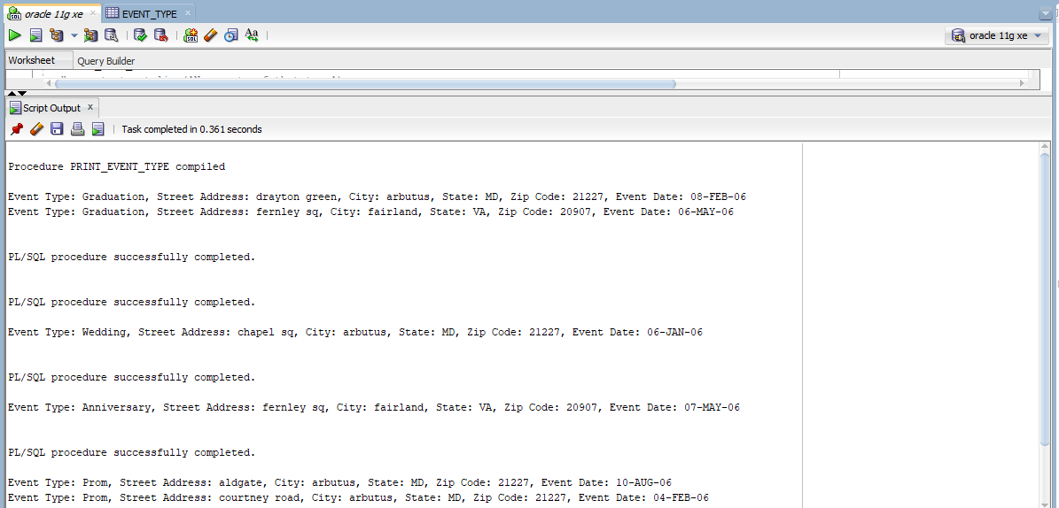

**----------------------------------------------------------------------------------------------------------------**

Solution 18 :

--procedure reservation_services_report

--show services on reservation: given a event reservation as input

--print service name and num of guests for each event per reservation id

CREATE OR REPLACE PROCEDURE reservation_services_report(eventreservationid IN event_reservation.event_reservation_id%TYPE)

IS

CURSOR c1 IS SELECT services.service_type , event_reservation.num_of_guests from services,services_for_events,event_reservation

where

services.service_id = services_for_events.service_id AND services_for_events.event_reservation_id = eventreservationid;

--@param service_type - String for service type

--@param num_of_guests - Count of number of guests

--@param service_id - Unique ID for services

--@param event_reservation_id - Unique ID for reservations

--variables to hold output from cursor

--of type service_type and num_of_ guests from services and event_reservation

servicename SERVICES.service_type%TYPE;

numofguests event_reservation.num_of_guests%type;

BEGIN

OPEN c1;

LOOP

--fetching cursor into holding variables service name, no of guests---

FETCH c1 into servicename,numofguests;

EXIT WHEN c1%NOTFOUND;

---Printing the output of Service name and no of guests ---

DBMS_OUTPUT.PUT_LINE('service name is :' ||servicename);

DBMS_OUTPUT.PUT_LINE('number of attendees is :' ||numofguests);

END LOOP;

close c1;

--Handling the exception ---

EXCEPTION

WHEN no_data_found THEN

DBMS_OUTPUT.PUT_LINE('No services for this reservation!');

END;

--- Execution of the procedure ---

exec reservation_services_report(11);

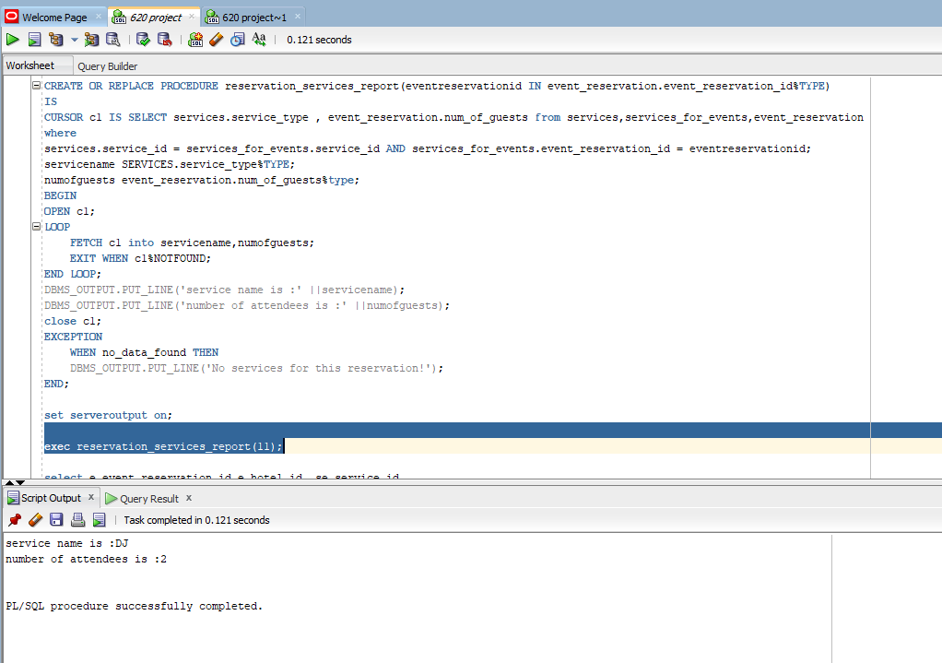

Solution 19 :

---Procedure specific_service_report

---Displaying the reservation by inputing the service name

create or replace procedure specific_service_report(service_name IN services.service_type%TYPE)

IS

Cursor c1 is

select e.event_reservation_id,e.hotel_id, se.service_id

from event_reservation e,services_for_events se, services s where e.event_reservation_id=se.event_reservation_id and s.service_type = service_name ;

--- @param reservation_id

--- @param service_id

--- @param hotel_id

--- @param service_type

--- Variables to handle the output cursor---

eventreservation event_reservation.event_reservation_id%type;

hotelid event_reservation.hotel_id%type;

serviceid services.service_id%type;

BEGIN

OPEN C1;

LOOP

FETCH c1 into eventreservation,hotelid,serviceid;

EXIT WHEN c1%NOTFOUND;

---Outputing the Event reservation,Hotel ID and Service id's after executing the procedure---

DBMS_OUTPUT.PUT_LINE('event reservation is :'||eventreservation);

DBMS_OUTPUT.PUT_LINE('hotelid is :'||hotelid);

DBMS_OUTPUT.PUT_LINE('servicesid is :'||serviceid);

END LOOP;

close c1;

---Handling the required exception ----

EXCEPTION

WHEN no_data_found THEN

DBMS_OUTPUT.PUT_LINE('No reservations for this service');

END;

EXEC specific_service_report('DJ');

